Mata Masu Dubara

CARE’s long-term development project softens the blow of
Niger’s food crisis

Loetitia Raymond / August 2005

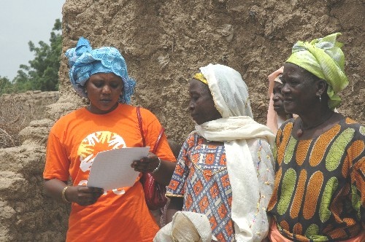
List in hand, Brounga Habsatou, a CARE field agent in Niger’s Maradi region, calls the women of Madarounfa for today’s distribution. Each woman will receive a 50-kilogram sack of grain husks that she will use to feed the small livestock – goats, sheep – that are her economic mainstay.
Women are summoned for the distribution of animal feed.

At the same time, the men of Madarounfa are lining up to receive food for their families. CARE is distributing a 50-kilogram sack of millet for each household. Because men traditionally own the crops produced by the entire family, it is they who are receiving the millet today while their wives collect the animal feed.

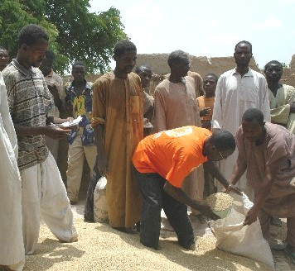
Why give food to animals while men, women and children are hungry? By distributing emergency aid to those who have nothing, CARE helps people survive. By distributing fodder so women can feed their animals, CARE helps them ensure their future revenue and avoid a crippling dependence on food aid.
Men, meanwhile, gather to receive millet.

The people in many of Niger’s villages have no more to eat, and their animals suffer alongside them. Pasturelands barren, herders cannot afford to buy food for their livestock. With the fodder distributed today, women in Madarounfa can continue to fatten their animals and sell them on the market for a profit. And their families can live off that income until the upcoming harvest. It’s simple, it’s clever – and it works!

Most of the women in Madarounfa are members of Mata Masa Dubara, or MMD, groups. The MMD project, created by CARE 15 years ago, has helped about 171,000 women across all of Niger to gain access to small loans with which to develop income-generating activities. Each MMD group is made up of 30 to 35 women, and each woman commits to saving a small sum every week in the group’s cashbox. The cashbox serves as a revolving credit fund. Members borrow small sums to launch or expand a money-making activity. The women then reimburse the cashbox, with interest at a reasonable rate agreed by the group, and the money is available for more small loans. Thus without collateral, letters of recommendation or even a piece of identification, these women – all of whom would be rejected as poor risks by a traditional bank – build a reliable and ready source of credit.

If by chance a woman is unable to repay her loan, other MMD members will cover her debt until she can. This solidarity is impressive but also practical: when all members feel responsible to one another, they will go to any lengths to fulfill their financial obligations to the group.

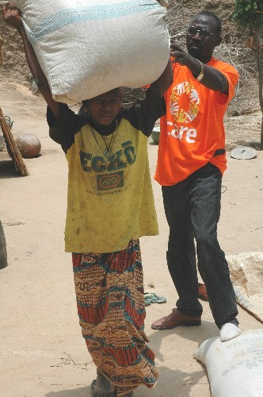
Rahamou Bala is waiting her turn to receive a sack of fodder. She belongs to an MMD group – in fact, she has been president of her group for a number of years. At 55 years old, Rahamou and her seven children have endured other difficult times but she says she has never seen anything like the current food crisis. Still, her situation is better than that of women who do not participate in the savings and credit program. Those women had no means to stave off their family’s hunger, while Rahamou and her MMD peers worked as a group to lessen the impact of the food crisis.
A CARE field agent helps a woman lift the sack of animal feed. In spite of its 50 kilograms of weight, she will carry the sack home unaided.

“When last year’s harvest began, we saw how bad it would be,” explains Rahamou. “We got together to discuss the future. I knew that we wouldn’t have enough food to get us through, that prices for grain would rise and it would get harder and harder to buy food. So I sold some livestock right away while the prices were still high, because I knew that buyers would pay less for animals as time passed.”

Rahamou’s husband cultivates millet while she fattens animals. That is, she buys young or skinny animals – sheep and goats, mostly – and feeds them well before reselling them at a profit. This business is particularly rewarding when she times her sales to coincide with holidays and celebrations, many of which traditionally involve the slaughter of a sheep. Rahamou also grows peanuts as a cash crop.

Rahamou began with two ewes, each of which gave birth four times. She sold the offspring for use in marriage feasts. She invested her profits, augmented by small loans from the MMD group, in other sheep. She bought each animal at 15,000 francs and sold it for double the amount.

When the current crisis began to loom, she sold two bulls, which are second only to camels in Niger for their high value. Rahamou sold shrewdly and got 115,000 francs per beast; today, a bull brings barely half that.

Rahamou also explains how other MMD members developed safety nets against the crisis. Her MMD group bought peanuts just after last year’s harvest, when peanuts flooded the market and their price was low. Now they have peanuts to eat or to sell at a higher price. They put their millet stocks to use, selling to group members at good prices. The women can pay back the millet in cash, in kind or with a quantity of peanuts at a parallel value. This clever system benefits everyone, and the women did not deplete the MMD cashbox: at harvest, members will be able to pay back what they owe.

“The situation is difficult, but compared to families that don’t have access to MMD, we’re not doing badly at all,” observes Rahamou. Thanks to the CARE project, we have been able to come up with all these ideas. Other women don’t have the opportunity to get together like we MMD members do, they don’t discuss their problems together and come up with these solutions,” she continues with a hint of pride. “Without the MMD group and its stock, I’d have been able to hang on four or maybe five months with what we harvested last year. But with it, I’ve hung on until now. And the arrival of aid from CARE now means that we will be able to hang on until harvest begins.”
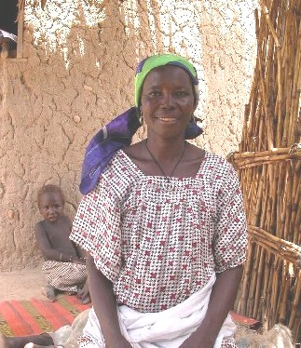
Rahamou Bala describes how her MMD group has helped Madarounfa in today’s crisis.
Rahamou reflects on how MMD membership has changed her life. “In 1998, which was also a very bad year, I wasn’t part of a group and things were really hard. Without the project this year, I wouldn’t have known when to sell my livestock and my family would have suffered. I was able to borrow when others were not.”

A number of the women at the distribution site chime in. All agree that MMD membership has helped expand their knowledge – in fact, they mention this more than the expansion of their income. Working together has offered them new ways of thinking, new ways of solving problems. “We share our ideas and discover new things,” says one woman, “and the best thing is, we teach these things to our children.”

